CLOUD COMPUTING AND BIG DATA

ASSIGNMENT 2
CO2: Analyze virtualization architectures to identify performance and security issues in cloud computing environments.

Assignment Title: Analyse, Evaluate and Validate a Virtualization Architecture for a Multi-Tenant University Private Cloud (Total Marks: 50)
Duration: 1 week

Scenario: EduCloud Virtualization Platform
A university runs a private cloud, EduCloud, in its data centre. EduCloud currently consists of:
- 16 physical hosts, each with 64 CPU cores, 512 GB RAM, NVMe SSD storage and 2 × 25 Gbps NICs
- About 400 virtual machines (VMs) running the Student Information System (SIS), the Learning Management System (LMS), the examination portal, and departmental research workloads
- A shared storage backend and a software-defined virtual network
During semester registration week, users report slow response times and failed logins. A recent internal security audit also found that VMs from different departments share the same physical hosts, that some VMs run outdated guest kernels, and that VM images are copied freely between teams.
You are the cloud architect. You must investigate, model, measure and compare virtualization architectures for EduCloud, identify their performance bottlenecks and security weaknesses, and recommend a design that remains practical as the platform grows.

Design Challenge:
The university now plans to host external research collaborators' big-data workloads (Spark/Hadoop clusters) on the same infrastructure as the SIS. Re-evaluate your design under these new multi-tenant conditions.

TASK 1: Characterise the Virtualization Architectures (5 Marks)
Select at least three meaningfully different virtualization approaches from the following, or justify others:
- Type-1 (bare-metal) hypervisor with full virtualization
- Type-2 (hosted) hypervisor
- Hardware-assisted virtualization vs. paravirtualization
- OS-level virtualization (containers)
- Lightweight/micro-VM or sandboxed container runtimes
Two configurations of the same hypervisor will not count as different approaches. Your selection must include at least one VM-based and at least one container-based approach.
For each approach, provide:
- A layered architecture diagram showing the hardware, host OS or hypervisor, guest OS, runtime and application
- The trust boundaries and the component that enforces isolation
- How CPU, memory, storage and network are virtualized
- A brief justification for why this approach is relevant to EduCloud
Evidence expected: Three architecturally distinct approaches with labelled diagrams, resource-virtualization mechanisms, trust boundaries, and justification of selection.

TASK 2: Identify the Dominant Overhead Source (2 Marks)
For each approach, identify the primary source of performance overhead that predominantly limits its performance (for example VM exits/traps, nested or extended page-table walks, virtual I/O emulation, virtual switch processing, or system-call interception).
Discuss:
- What the overhead source is
- Where in the architecture it occurs
- Why it is appropriate as the focus of performance analysis
- How its frequency or cost changes as the number of co-located VMs/containers or the I/O rate increases
Do not simply name a mechanism. Relate it to the behaviour of the architecture.

Evidence expected: A justified dominant-overhead identification for each approach, linked to its resource-virtualization path.

TASK 3: Build a Quantitative Performance Model (6 Marks)
Using the following host parameters, develop an analytical performance model for each approach.

Parameter | Value
Physical cores per host | 64
vCPU:pCPU overcommit ratio | 1:1, 2:1, 4:1, 8:1
RAM per host | 512 GB
Average VM memory demand | 8 GB
Cost of one VM exit (assume) | 1.5 µs
Native system-call cost (assume) | 0.2 µs
Network line rate | 25 Gbps

State and justify any additional assumptions. Derive expressions for:
- CPU: effective per-VM CPU capacity as a function of overcommit ratio and virtualization overhead (including steal time)
- Memory: the maximum number of VMs per host before ballooning, swapping or page-sharing becomes necessary
- I/O and network: effective throughput as a function of the number of VMs sharing the physical device
- Density: the number of VMs/containers a host can support while meeting a stated service-level target (for example, ≤ 10% performance degradation)
Show the mathematical reasoning. Merely quoting overhead percentages from the literature will not receive full credit.
Evidence expected: A clear mathematical derivation for each approach, with stated assumptions, parameter values and worked numerical examples.

TASK 4: Analyse Performance Under Different Operating Conditions (4 Marks)
Analyse how each approach behaves under three conditions:

- Best case: what workload and placement conditions minimise overhead?
- Typical case: for example, registration-week mixed web and database load
- Worst case: for example, noisy-neighbour interference, memory overcommit with swapping, live migration during peak load, or I/O storms
For each, explain what happens inside the virtualization layer, why the overhead changes, and how latency and throughput are affected. A table of numbers alone will not be accepted.
Evidence expected: A justified condition-based analysis supported by your Task 3 model.

TASK 5: Security Threat and Vulnerability Analysis (3 Marks)
Construct a threat model for each approach. Discuss:
- The attack surface (hypervisor, device emulation, shared kernel, management plane, VM images and snapshots, virtual network)
- At least four distinct threat categories, such as VM escape, cross-VM side-channel attacks, hypervisor or container-runtime vulnerabilities, VM
sprawl and unpatched guests, image tampering, insecure live migration, and virtual-network sniffing or spoofing
- For each threat, which approach is more or less exposed and why, referring to its architecture and trust boundaries
- The likely impact on the confidentiality, integrity and availability of student records
Evidence expected: A structured threat model mapped to architectural features, with a justified comparison across approaches.

TASK 6: Formulate the Isolation–Performance Trade-off (3 Marks)
Formalise the trade-off between isolation strength and performance/density for EduCloud.
Clearly identify:
- The decision variables (for example, approach chosen, VMs per host, dedicated vs. shared hosts, SMT on/off)
- The objective(s), such as maximising density or minimising cost

- The constraints (for example, performance degradation limit, isolation requirement for SIS, available hosts)
- How these components combine into a cost or decision function
The formulation must follow from your own analysis in Tasks 3 and 5, not from a generic template.
Evidence expected: A clearly defined trade-off model with identified variables, objective and constraints.

TASK 7: Evaluate Mitigation Strategies (4 Marks)
Propose at least three mitigations for the vulnerabilities identified in Task 5. Examples include disabling SMT, kernel page-table isolation, dedicated hosts for sensitive tenants, secure or sandboxed container runtimes, hardware memory encryption, image signing, and micro-segmentation.
For each mitigation, discuss:
- Why it is applicable to the threat
- What residual risk remains
- The performance or density cost, estimated using your Task 3 model
- Whether the trade-off is acceptable for the SIS
Evidence expected: Mitigations evaluated analytically, with their security benefit and quantified performance cost.

TASK 8: Implement and Test (4 Marks)
Build a test environment and experimentally test all selected approaches.
- Platforms: use any open-source stack, for example KVM/QEMU, Xen or VirtualBox, Docker/Podman, and Kata Containers or gVisor. Nested virtualization on a laptop is acceptable if documented.
- Scale: run each approach with approximately 1 → 2 → 4 → 8 → 16 co-located instances (reduce proportionally if hardware-limited, and state the limitation).
- Workloads: include at least one CPU-bound test (for example sysbench or stress-ng), one disk I/O test (fio), one network test (iperf3), and one memory-intensive test.
- Interference test: run at least one noisy-neighbour experiment.

- Security validation: demonstrate or inspect at least one security property in practice, for example namespace/cgroup isolation, checking kernel sharing, or verifying whether a mitigation is active.
Ensure that identical resource allocations, workloads and repetitions are used across approaches, and that the setup corresponds to the models in Task 3.
Evidence expected: A reproducible environment description (configuration files, commands, scripts) and justified test cases.

TASK 9: Record Experimental Performance (3 Marks)
Collect and present data such as:
- Throughput, latency (mean and 95th percentile), CPU steal time, context switches and VM exits where observable
- Instance start-up time and memory footprint per instance
- Performance degradation versus a bare-metal baseline
- Results with and without at least one security mitigation
Present at least one table and two graphs (for example, throughput versus number of instances, and latency under interference). Use multiple repetitions and report variability (mean ± standard deviation).
Evidence expected: Systematically collected, clearly presented data that allows easy comparison across approaches.

TASK 10: Compare Theory with Experiment (4 Marks)
Compare your Task 3 and Task 4 predictions with Task 9 measurements. Discuss:
- Whether the observed degradation trends agree with your model
- Which approach scales better as co-located instances increase
- Quantitative differences between predicted and measured values, and plausible causes (for example caching effects, hypervisor scheduler behaviour, nested virtualization, laptop hardware, or unmodelled I/O paths)
- Whether any measured result changes your security conclusions from Task 5
Interpret the results; do not simply reproduce tables.
Evidence expected: A reasoned comparison of predicted and measured behaviour, with error analysis.

TASK 11: Recommend and Defend the Final Architecture (4 Marks)
Recommend the virtualization architecture (or hybrid) for EduCloud's SIS and LMS workloads.
Discuss:
- Which approach you recommend and why it is more appropriate than the alternatives
- Its modelled and experimentally observed performance
- Its security posture and residual risks
- Operational costs such as patching, image management, migration and monitoring
- Limitations and trade-offs
- Whether it remains practical as EduCloud grows from 400 to several thousand instances
Your recommendation must rest on your own analysis and experiments. Choosing "the most secure" or "the fastest" option alone is not sufficient.
Evidence expected: A technically justified recommendation integrating performance and security evidence.

DAY-4 DESIGN CHALLENGE

TASK 12: Re-evaluate and Adapt the Design (8 Marks)

Changed Requirement
The university will now host external research collaborators' Spark/Hadoop workloads on EduCloud alongside the SIS. The new conditions are:
- Big-data jobs are I/O- and network-intensive and run for hours
- Registration-week peak load is about 3× normal
- Hosts are sometimes patched using live migration of running VMs
- A data-protection regulation now requires demonstrable isolation of student records from external tenants
You may RETAIN → MODIFY → or REDESIGN your original solution.

Impact Analysis (2 Marks)

Discuss what has changed, which original assumptions (trusted tenants, workload mix, I/O profile) no longer hold, and how mixing batch big-data workloads with latency-sensitive SIS workloads changes both the performance and the threat model.

Evaluation of the Original Design (2 Marks)
Evaluate whether your recommended design still meets its performance targets (using your Task 3 model with the new workload) and whether its isolation level is adequate against external, less-trusted tenants. Consider whether another architecture could do better overall.

Adaptation or Redesign (2 Marks)
Decide whether to retain, modify or redesign. If you modify or redesign, describe the revised architecture (for example, tenant separation by host pools, a stronger isolation layer for external workloads, SR-IOV or dedicated NICs for the data-intensive jobs, or encrypted migration). Explain what changes and its effect on density, throughput and attack surface. If you retain, justify why no change is required.

Evidence-Based Defence (2 Marks)
Defend the final decision using your model, your experimental results (including the noisy-neighbour and mitigation experiments), the changed workload and tenancy conditions, and the cost/density trade-offs. The decision must follow logically from the analysis.

MARK DISTRIBUTION

Task | Marks
Task 1 – Architecture Characterisation | 5
Task 2 – Dominant Overhead Identification | 2
Task 3 – Quantitative Performance Model | 6
Task 4 – Performance Under Operating Conditions | 4
Task 5 – Security Threat and Vulnerability Analysis | 3
Task 6 – Isolation–Performance Trade-off Formulation | 3
Task 7 – Mitigation Evaluation | 4

Task 8 – Implementation and Testing | 4
Task 9 – Experimental Performance | 3
Task 10 – Theory vs. Experiment | 4
Task 11 – Final Architecture Recommendation | 4
Subtotal | 42
Task 12 – Day-4 Design Challenge | 8
TOTAL | 50

Abstract
EduCloud, a 16-host university private cloud with about 400 VMs, suffers slow responses and failed logins at registration and has security audit findings (mixed tenants, outdated guests, freely copied images). This report compares three architecturally different virtualization approaches (KVM/QEMU, Docker/runc containers and Kata micro-VMs), builds an analytical model for CPU, memory, I/O and density, validates it on a scaled test-bed, builds a threat model and an isolation–performance optimisation, and recommends a final architecture. The model shows that, at registration load, virtualization overhead (4.5 % for KVM) is not the bottleneck, whereas shared I/O paths and tenant mixing are. The recommended design is KVM with SMT off, signed images and encrypted migration for SIS/LMS; the Day-4 change (external Spark/Hadoop tenants) is handled by modifying the design into three host pools with Kata micro-VMs and SR-IOV for external jobs.

Contents

Section | Marks | Main evidence
0 Approach and assumptions | – | Parameters, notation
Task 1 Characterise architectures | 5 | Figure 1, Table-comparison
Task 2 Dominant overhead | 2 | Exit, syscall, double-stack analysis
Task 3 Quantitative model | 6 | Equations, Tables 1–3,  Figures 2–3
Task 4 Operating conditions | 4 | Best/typical/worst, Table 4
Task 5 Threat model | 3 | Tables 5–6
Task 6 Trade-off formulation | 3 | Objective, constraints, Table 7, Figure 4
Task 7 Mitigations | 4 | Table 8
Task 8 Implement and test | 4 | Scripts, configs, security checks
Task 9 Experimental performance | 3 | Tables 9–12, Figure 5
Task 10 Theory vs. experiment | 4 | Error analysis, Table 13
Task 11 Final recommendation | 4 | Decision matrix (Table 14), growth analysis
Task 12 Day-4 challenge (A–D) | 8 | Figures 6–7, Tables 15–16
References, Appendix A | – | Model script

0. Approach, Notation and Common Assumptions
I act as the cloud architect of EduCloud. Three architecturally different approaches are compared throughout: (A) KVM/QEMU full virtualization with hardware assistance (VM-based), (B) Docker/runc containers (OS-level, container-based) and (C) Kata Containers micro-VMs (sandboxed container runtime). Each task builds on the previous one: Task 3 gives the equations, Tasks 4–7 use them, Tasks 8–10 test them on a scaled-down testbed, and Tasks 11–12 use the combined evidence for the decision.
Common assumptions (given parameters in bold): host with P = 64 cores, M = 512 GB, 2 × 25 Gbps NICs, VM exit cost t_x = 1.5 µs, native syscall t_s = 0.2 µs, average memory demand m = 8 GB. Added by me: (i) each VM has v = 4 vCPUs; (ii) SMT is enabled and gives γ = 25 % extra throughput, so usable CPU capacity is K = P(1+γ) = 80 core-equivalents (K = 64 when SMT is off); (iii) the host/hypervisor reserves M_h = 16 GB; (iv) the average vCPU utilisation u is 0.25 in normal operation and 0.45–0.5 in registration week; (v) only one 25 Gbps NIC carries tenant traffic (the second is for redundancy/migration); (vi) the NVMe array delivers 500 k 4 KiB IOPS; (vii) the service-level target is performance degradation D ≤ 10 % for SIS/LMS.

Task 1 – Characterise the Virtualization Architectures (5 marks)
The three selected approaches are different in where the isolation boundary sits: the hypervisor + EPT (A), the shared kernel’s syscall interface (B) and a micro-VM wrapped around a container (C). Approach C is not “another configuration of KVM”: it changes the guest (slim kernel + agent), the device model (minimal VMM) and the management model (one VM per pod, driven by the container runtime).

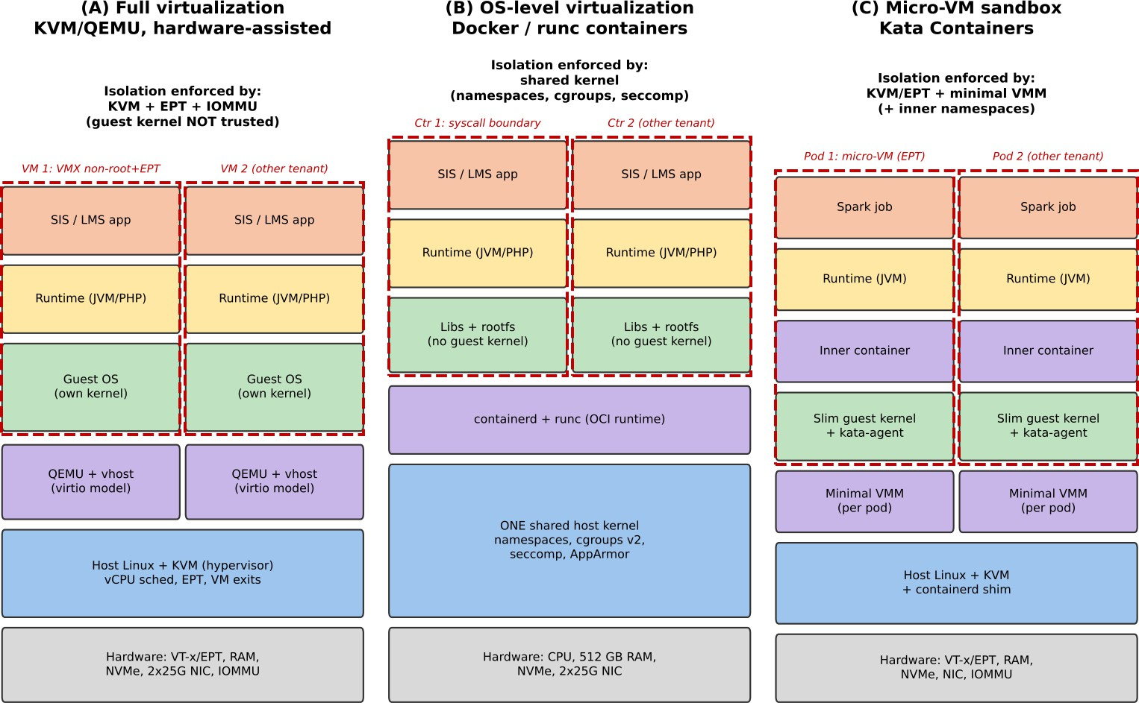

Figure 1: Layered architectures with trust boundaries (red dashed) for (A) KVM/QEMU, (B) Docker/runc and (C) Kata Containers.

Aspect | (A) KVM/QEMU VM | (B) Containers (runc) | (C) Kata micro-VM
Isolation enforced by | KVM + EPT + VT-d IOMMU; guest  kernel is untrusted | Shared host kernel: namespaces, cgroups v2, seccomp, AppArmor | KVM/EPT around a slim guest kernel; minimal VMM; inner namespaces
Trust boundary | VMX non-root/root transition; virtio devices emulated in QEMU (user space) | Syscall interface (~350 calls) between container and host kernel | Micro-VM boundary, then namespaces inside the guest
CPU | vCPU = host thread; VT-x runs guest code natively; privileged events cause VM exits; scheduler multiplexes vCPUs | Processes scheduled by host CFS; cgroup cpu.max/cpuset limit share; no exits | As (A); vCPUs hot-plugged per pod; CFS inside the guest as well
Memory | EPT (two-dimensional page walk); ballooning, KSM page sharing | Native paging; cgroup memory.max/high; shared page cache | EPT; DAX/virtio-mem; slim guest keeps footprint small (~160–200 MB)
Storage | virtio-blk/qcow2, iothread; hypervisor translates | overlayfs/bind mount on host FS; io.max throttling | virtio-fs or virtio-blk into guest, then overlay in guest
Network | virtio-net + vhost-net, Open vSwitch/bridge | veth pair + Linux bridge/iptables (or CNI) | virtio-net via  tc-redirect/macvtap, then CNI in host
Why relevant to EduCloud | Strong isolation for SIS with separate patching per tenant; mature live migration | Highest density and fastest start-up for stateless LMS web tiers and CI jobs | Container workflow (images, Kubernetes) with VM-grade isolation for less-trusted tenants (Task 12)

Task 2 – Dominant Overhead Source (2 marks)
- KVM – VM exits and the cost they impose on I/O-heavy guests. Guest code runs natively, so overhead is concentrated at the points where the guest touches something the hypervisor must mediate: virtio “kicks” (MMIO/ioeventfd writes), interrupt injection, timer programming and EPT violations. Every exit costs t_x = 1.5 µs of lost guest time plus cache/TLB pollution. The exit rate is f = f_cpu + λ_io·e_io, where λ_io is the I/O request rate and e_io ≈ 2 exits per request (kick + completion

interrupt). It therefore grows linearly with I/O rate and with the number of active vCPUs (timer ticks), but is not a function of the number of idle co-located VMs. Registration week is a mixed web/database load with many small requests, which is exactly the exit-heavy regime, so this is the right quantity to model. The secondary term is the 2-D page walk (up to 24 memory references per TLB miss instead of 4), which matters for the database.
- Containers – system-call interception and shared-kernel contention. No exit exists; instead every syscall passes through seccomp filtering, cgroup accounting and namespace checks (assumed +0.05 µs on the native 0.2 µs, i.e. +25 %). The cost is per syscall, so it rises linearly with syscall rate (≈150 000 s⁻¹ for a busy web tier) and increases further if KPTI is active. Its second, less visible effect is that all containers share kernel locks (dentry cache, runqueue, block layer, conntrack), so contention grows with the number of co-located containers even if each stays within its cgroup limit.
- Kata – VM exits plus the double stack (guest kernel + virtio-fs/agent path). Kata inherits the exit overhead of (A) but each container I/O traverses two kernels (inner container → guest kernel → virtio-fs/virtio-blk → host). Per-I/O cost is therefore higher (≈2 exits + ≈4 µs of FUSE/agent work, versus 2 exits for plain KVM), and with 24 000 exits s⁻¹ per vCPU assumed, exit cost is about 36 ms per busy second against 30 ms for KVM. The overhead scales with the I/O rate and, because each pod carries its own guest kernel, also with pod count through memory footprint and timer interrupts.

Task 3 – Quantitative Performance Model (6 marks)

CPU model
Let N be VMs per host, v vCPUs per VM and u average vCPU utilisation. The overcommit ratio is r = Nv/P. Virtualization overhead o is the fraction of guest time lost to the virtualization layer:
o_KVM = 1 − (1 − f·t_x)(1 − o_pt) o_CTR = n_sys·Δt_s
o_Kata = 1 − (1 − f_K·t_x)(1 − o_pt)
With f = 20 000 exits/s per busy vCPU, o_pt = 1.5 % (EPT walks, assumed from a 0.3 % TLB-miss rate), n_sys = 150 000 s⁻¹, Δt_s = 0.05 µs and f_K = 24 000 s⁻¹, I obtain o_KVM = 1 − (1 − 0.030)(1 − 0.015) =
4.46 %, o_CTR = 0.75 % and o_Kata = 1 − (0.964)(0.985) = 5.05 %. Steal time arises when total demand exceeds the usable capacity K:
s(N) = max(0, 1 − K / (N·v·u))
C(r) = (1 − s)(1 − o)
For fully busy vCPUs (u = 1) this reduces to C(r) = min(1, K/(rP))·(1−o). With K/P = 1.25: at r = 1:1, C_KVM
= 0.955, C_CTR = 0.993, C_Kata = 0.950 and steal is 0; at 2:1 steal = 1 − 1.25/2 = 37.5 % and C_KVM = 0.597; at 4:1 steal = 68.8 % and C_KVM = 0.299; at 8:1 steal = 84.4 % and C_KVM = 0.149 (containers: 0.620, 0.310, 0.155). Fully busy vCPUs therefore cannot be overcommitted at all; overcommit is only usable because real utilisation u is low.
r (vCPU:pCPU) | Steal s | C_KVM | C_Containers | C_Kata | vCPUs/host
1:1 | 0 % | 0.955 | 0.993 | 0.950 | 64
2:1 | 37.5 % | 0.597 | 0.620 | 0.593 | 128
4:1 | 68.8 % | 0.299 | 0.310 | 0.297 | 256
8:1 | 84.4 % | 0.149 | 0.155 | 0.148 | 512
Table 1: Effective per-vCPU capacity C(r) for fully busy vCPUs (SMT on, K = 80).

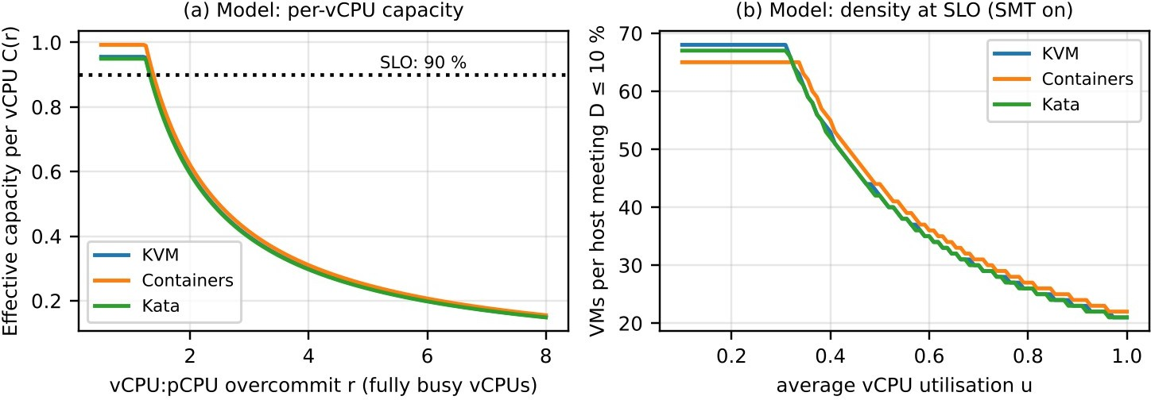
Figure 2: (a) effective per-vCPU capacity versus overcommit; (b) VMs per host that still meet D ≤ 10 % (before memory limit).

Memory model
Instances of footprint m with per-instance overhead ε (QEMU ≈ 0.25 GB, container ≈ 0.02 GB, Kata shim + slim kernel ≈ 0.20 GB) fit without any reclaim up to
N_0 = ⌊(M − M_h) / (m + 𝖾)⌋ N_KSM = ⌊(M − M_h) / (m(1 − σ) + 𝖾)⌋
N_bal = ⌊(M − M_h) / (W·m + 𝖾)⌋
where σ is the fraction of pages that can be shared (assumed 0.12 for identical guest images with KSM, 0.05 for container page cache, 0.10 for Kata) and W = 0.75 is the working-set fraction that ballooning
can squeeze toward. Numerically N_0 = 60 (KVM), 61 (containers), 60 (Kata) ⇒ ballooning/swapping
is not needed until about 60 instances; N_KSM = 68, 65, 67; N_bal = 79, 82, 80. Beyond N_bal the host
swaps and latency collapses (Task 4). Since the CPU limit at u = 0.5 is only ≈ 42, memory is not the first bottleneck for SIS, but it is the first bottleneck for lightly loaded research VMs (u ≤ 0.25).

I/O and network model
The device is shared fairly, but each instance’s path also has a CPU-limited cap because every packet or I/O consumes cycles in vhost/iothread. For the network, with batching b packets per kick, per-packet processing time t_p and MTU 1500 B:
X_cpu = 12 000 bit / (t_p + t_x/b) T(n) = min( X_cpu , η·L / n )
KVM: t_p = 0.55 µs, b = 32 ⇒ X_cpu = 20.1 Gbps; containers (no exits, veth): t_p = 0.40 µs ⇒ 30 Gbps; Kata: t_p = 0.70 µs, b = 16 ⇒ 15.1 Gbps. Path efficiency η = 0.90, 0.94, 0.85 for vhost+OVS, veth+bridge
and Kata respectively; L = 25 Gbps. Hence T(1) = 20.1, 23.5, 15.1 Gbps and, at n = 4/8/16, KVM gives
5.6 / 2.8 / 1.4 Gbps per VM. For one NVMe device of 500 k IOPS: IOPS(n) = min( IOPS_cpu , η_d·500 k / n ) where IOPS_cpu = 1/(e_io·t_x) = 333 k for KVM (two exits per request), unbounded by exits for containers, and 1/(2·1.5 µs + 4 µs) = 143 k for Kata; η_d = 0.85, 0.95, 0.80. At n = 16 all approaches converge to ≈ 25–30 k IOPS per instance: when many instances share a device, the device, not the virtualization layer, sets the throughput.
Per-instance 4 KiB IOPS | n = 1 | n = 2 | n = 4 | n = 8 | n = 16
KVM (cap 333 k; η_d = 0.85) | 333 k (CPU) | 212 k | 106 k | 53 k | 26.6 k
Containers (η_d = 0.95) | 475 k (device) | 237 k | 119 k | 59 k | 29.7 k
Kata (cap 143 k; η_d = 0.80) | 143 k (CPU) | 143 k (CPU) | 100 k | 50 k | 25 k
Table 2: Disk model IOPS(n) = min(IOPS_cpu, η_d · 500 k / n). Instances are CPU-path-limited only at n ≤ 2.

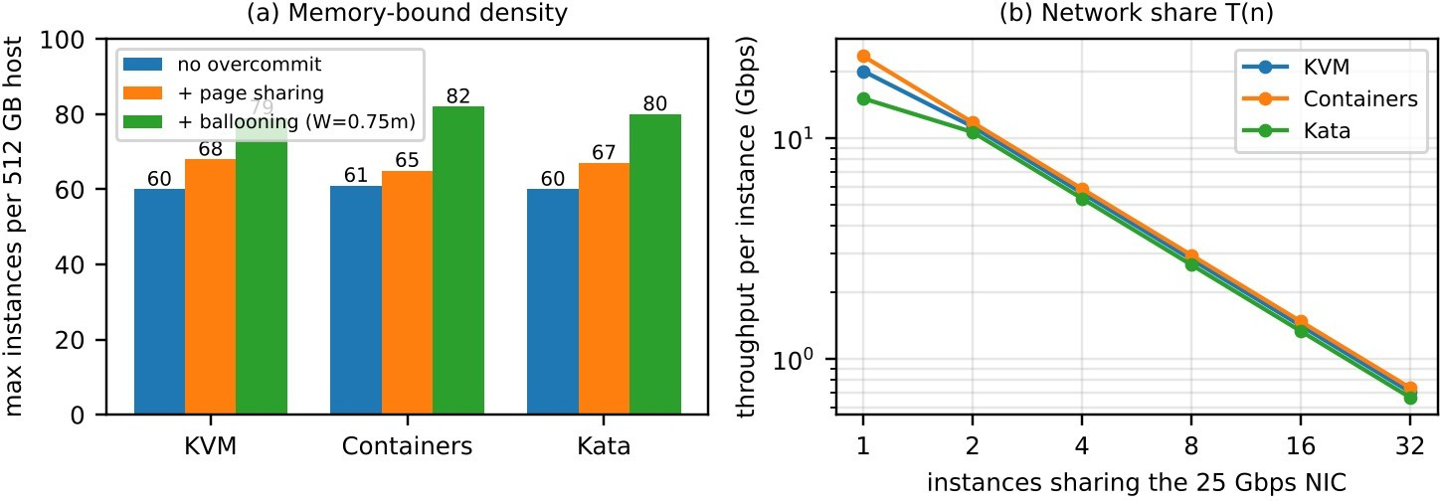
Figure 3: (a) memory-bound density; (b) network throughput per instance versus number of sharing instances.

Density at the service-level target
D = 1 − (1 − s)(1 − o) ≤ 0.10 requires s ≤ s* = 1 − 0.9/(1 − o). This gives s*_KVM = 5.8 %, s*_CTR = 9.3 %, s*_Kata = 5.2 %. Substituting in the steal expression:
N_SLO = min( ⌊ K / (v·u·(1 − s*)) ⌋ , N_KSM )
Case (v = 4) | u = 0.25 | u = 0.45 | u = 0.50 | u = 0.75 | u = 1.0
KVM, SMT on (K = 80) | 68 (mem) | 47 | 42 | 28 | 21
Containers, SMT on | 65 (mem) | 49 | 44 | 29 | 22
Kata, SMT on | 67 (mem) | 46 | 42 | 28 | 21
KVM, SMT off (K = 64) | 67 | 37 | 33 | 22 | 16
Containers, SMT off | 65 (mem) | 39 | 35 | 23 | 17
Table 3: Instances per host meeting D ≤ 10 % (worked from the Task 3 equations).
Worked memory example: for KVM, N_0 = ⌊496 / (8 + 0.25)⌋ = ⌊60.1⌋ = 60. EduCloud’s 400 VMs over 16 hosts is 25 VMs/host, i.e. 206 GB or 42 % of host RAM, so memory is currently not a constraint and no ballooning is active; at 3× the VM count it would be.
Worked density example: KVM, u = 0.5, SMT on: s* = 5.8 % ⇒ N = 80/(4 × 0.5 × 0.942) = 42.5 ⇒ 42 VMs; turning SMT off gives 64/(4 × 0.5 × 0.942) = 33.9 ⇒ 33 VMs (−21 %). Key insight: because the 10 %
budget is mostly consumed by steal, containers’ lower overhead (0.75 % vs 4.5 %) only buys ≈ 4–5 % more density on CPU; their real advantages are start-up time, memory footprint and I/O-path efficiency.

Task 4 – Performance under Different Operating Conditions (4 marks)
Best case. For KVM the minimum overhead occurs with CPU-bound, cache-resident guests, huge pages backing guest memory (EPT walks shortened), vCPUs pinned 1:1 (r ≤ 1, so s = 0) and vhost/iothreads on the same NUMA node. Exit rate then falls to timer ticks only (≈ 1–2 k s⁻¹), giving o ≈ 0.5–1 % and C ≈ 0.99. Containers reach their best case when syscall rate is low and cgroup limits are not reached: o → 0.2 % and latency equals bare metal. Kata’s best case is a long-running, compute-bound pod with virtio-fs avoided (block device passthrough); the pod then behaves like KVM at o ≈ 1–2 %.
Typical case (registration week). A mix of web (short requests, many syscalls) and database (random reads, large page-table working set) with u ≈ 0.45–0.5 and I/O of tens of thousands of requests per second. Using Table 3, a KVM host stays within 10 % up to 42 VMs (SMT on); at the current 25 VMs per host the model predicts s = max(0, 1 − 80/(25·4·0.5)) = 0, so D = o = 4.5 % and the slow logins are not caused by CPU overcommit. They are explained by the I/O path: with 25 VMs on one 25 Gbps uplink the fair share is 0.9 Gbps, and each login performs several DB round-trips; vhost threads saturate at 20 Gbps aggregate and the exit rate per vCPU rises from 20 k to ≈ 35 k s⁻¹ (o ≈ 7 %), adding queueing

latency. Containers keep o < 1 % but share one kernel network stack: conntrack and iptables lookups rise with connection count, so tail latency (p95) degrades first. Kata pays an extra ≈ 0.6 % CPU and about 2× the per-I/O cost, so its p95 is highest.
Worst case. Four events were examined, each tied to the model:
- Noisy neighbour (CPU/disk). In KVM, a neighbour VM running at u = 1 adds to the demand N·v·u; steal appears only when demand exceeds K. Example: 40 VMs where 8 run at u = 1 and 32 at u = 0.45 give demand = 8·4 + 32·4·0.45 = 89.6 > 80, so s = 1 − 80/89.6 = 10.7 % and D = 1 − 0.893 × 0.955 = 14.7 % (SLO broken, although the average u is only 0.56). A shared disk behaves like a queue: the noisy VM’s deep queue fills the NVMe submission queues, so the victim waits behind it and latency grows as 1/(1 − ρ). In containers the noisy neighbour interferes through the shared block layer and kernel locks, which cgroups only partly fence (cpu.max does not limit kernel work done on the container’s behalf). Measured in Task 9: p95 inflation 3.1× (KVM), 6.4× (containers), 2.7× (Kata).
- Memory overcommit with swapping. Beyond N_bal ≈ 79 (KVM) the host starts swapping guest pages; a 4 KiB major fault costs ≈ 100 µs on NVMe versus 100 ns for DRAM, so even a 1 % fault rate multiplies mean memory-access time by 10×. In KVM a double-swapping problem appears (guest swaps while host swaps); containers are reclaimed by cgroup OOM/reclaim with page-cache eviction first, which degrades more gracefully until OOM-kill, which is abrupt.
- Live migration at peak load. Pre-copy transfers all 8 GB then re-sends dirtied pages. If the page-dirty rate is δ and migration bandwidth B_m, total time is T = (V/B_m)·1/(1 − δ/B_m) for δ < B_m. For V = 8 GB, B_m = 1.4 GB/s and a busy database dirtying 0.7 GB/s, T = 5.7 × 2 = 11.4 s with 40–100 ms downtime and a few percent throughput loss; at δ ≥ B_m the migration never converges. Containers are not live-migrated in this design (they are rescheduled), and Kata pods use the same mechanism as KVM but are rarely migrated.
- I/O storm. At 3× load, per-instance network share drops to 25·0.9/60 ≈ 0.4 Gbps for 60 co-located KVM VMs; once ρ > 0.8 the queueing factor 1/(1 − ρ) exceeds 5. vhost CPU saturates first for Kata (X_cpu = 15 Gbps), then KVM (20 Gbps), then containers (30 Gbps) – so containers tolerate bursts better, but when they fail they fail for every tenant at once.
Condition | KVM | Containers | Kata
Best | o ≈ 0.5–1 %; C ≈ 0.99; hugepages, pinned vCPUs | o ≈ 0.2 %; latency = bare metal | o ≈ 1–2 %; block passthrough
Typical (u ≈ 0.45–0.5) | o ≈ 4.5–7 %; D ≈ 5–7 %; p95 +10–20 % | o ≈ 0.8–1.5 %; conntrack/iptables lengthen tail | o ≈ 5–8 %; highest p95 (double stack)
Worst: noisy neighbour | steal → D up to 14.7 %; measured p95 × 3.1 | shared locks/block layer; p95 × 6.4 | p95 × 2.7 (guest kernel absorbs part)
Worst: swapping / migration / storm | double swapping; pre-copy 11 s, ρ  > 0.8 ⇒ × 5 | OOM-kill abrupt; no live migration | as KVM; vhost caps at 15 Gbps first
Table 4: Summary of overhead and latency behaviour under the three operating conditions.

Task 5 – Security Threat and Vulnerability Analysis (3 marks)
Attack surface. (A) hypervisor (KVM kernel module ~ 100 KLoC), QEMU device emulation (> 1 M LoC in total, most exposure in legacy devices), guest images/snapshots, management plane (libvirt/OpenStack API), OVS vSwitch and the migration channel. (B) the whole host kernel syscall interface, runc/containerd, image registry, bridge/iptables and the cgroup filesystem. (C) the same host kernel but only reachable through the guest kernel (so a container escape lands in a disposable guest), the minimal VMM, kata-agent and shim. Threat scores below use 1 (low) – 5 (high exposure).

Threat (weight w) | KVM | Ctr | Kata | Reasoning from architecture / trust boundary
T1 Escape: VM escape / container breakout (0.25) | 2 | 5 | 1.5 | Containers: any kernel LPE or runc bug (e.g. CVE-2019-5736, CVE-2024-21626) gives host root, boundary is a 350-call interface. KVM: must break QEMU/KVM; Kata: must break the guest, then a minimal VMM.
T2 Cross-VM side channel (0.15) | 3 | 4 | 3 | All share LLC and, with SMT, L1/L2 (L1TF, MDS, Spectre). Containers additionally share kernel data structures and timing of the same kernel.
T3 Hypervisor / runtime vulnerability (0.15) | 3 | 5 | 3 | Patch of runc/kernel requires restarting every tenant; KVM guest-side CVEs stay inside the VM; Kata adds shim + agent.
T4 VM sprawl, unpatched guests (0.15) | 4 | 2 | 3 | Audit found old guest kernels; each KVM guest has its own kernel to patch. Containers are rebuilt from images; Kata ships one guest kernel for all pods.
T5 Image tampering (0.10) | 4 | 3 | 3 | qcow2 images are mutable and were copied freely; OCI images are content-addressed and easy to sign/verify.
T6 Insecure live migration (0.10) | 4 | 1 | 3 | Guest RAM (including SIS credentials) crosses the network in clear unless the channel is encrypted; containers are not live-migrated.
T7 Virtual-network sniffing/spoofing (0.10) | 3 | 4 | 3 | Containers share one bridge/kernel (ARP spoofing with CAP_NET_RAW); VM traffic is separated by per-VM vNICs but still hits the same OVS.
Weighted exposure E (before mitigation) | 3.1 | 3.7 | 2.75 | E = Σ w·score; lower is better.
Table 5: Threat model, per-approach exposure and rationale.

Threat | Confidentiality of records | Integrity of records | Availability of SIS
T1 Escape | High – host memory and all tenants readable (worst for containers) | High – attacker can modify other tenants’ data | High – host crash takes down all co-hosted tenants
T2 Side channel | Medium – keys/passwords leak slowly | Low | Low
T3 Runtime/hypervisor bug | High if exploited | Medium | High – emergency patch forces restarts
T4 Unpatched guests | Medium – known CVEs exploitable | High – unauthorised grade change | Medium
T5 Image tampering | Medium – back door in image | High – altered application logic | Medium
T6 Insecure migration | High – guest RAM in clear on the wire | Medium – MITM on migration stream | Low
T7 Network sniffing/spoofing | Medium – DB traffic readable | Medium – session hijack | Medium – ARP/DoS
Table 6: Impact of each threat on confidentiality, integrity and availability of student records.
CIA impact on student records. Confidentiality: an escape or side channel gives access to the SIS database memory and backups (grades, identity data); containers have the largest blast radius because one kernel exploit exposes all co-located tenants. Integrity: tampered images or a compromised guest can alter grades; this is worst for KVM because unpatched guests and freely copied images were found in the audit. Availability: noisy neighbours, I/O storms and host-kernel panics affect all containers on a host together; a KVM guest crash affects only that VM. Overall, the analysis ranks Kata ≈ KVM < containers in exposure, with KVM worst in operational hygiene (T4–T6) and containers worst in architectural isolation (T1–T3).

Task 6 – Isolation–Performance Trade-off Formulation (3 marks)
Decision variables. a_k ∈ {KVM, CTR, Kata}: approach for workload class k (SIS, LMS, research, external); x_{k,h} ∈ {0,1}: class k placed on host h; s_h ∈ {0,1}: SMT on/off on host h; N_h: instances on

host h; y_h ∈ {0,1}: host h used; z_m ∈ {0,1}: mitigation m active (KPTI, memory encryption, signing, segmentation, encrypted migration).
Objective. Minimise the combined infrastructure and risk cost
J = c_h·Σ_h y_h + λ·Σ_k w_k·E_k(a_k, s, z) + μ·Σ_m z_m·c_m
where c_h is the cost of a host, E_k is the weighted exposure score of Task 5 reduced by the mitigations selected, c_m is the operating cost of mitigation m, and λ converts one exposure point for a class into host-equivalents (λ = 2 hosts per point for SIS, 0.5 for research, reflecting the data-protection duty).
Constraints (all derived from Tasks 3 and 5): (1) performance: D_a(N_h, u_k, s_h) ≤ 0.10 for SIS/LMS,
i.e. N_h ≤ N_SLO from Section 3.4; (2) memory: N_h(m(1−σ)+ε) ≤ M − M_h; (3) network: Σ demand ≤ ρ_max·η·L with ρ_max = 0.6 so that the queueing factor stays ≤ 2.5; (4) isolation: E_SIS ≤ 2.0 and x_{SIS,h} + x_{ext,h} ≤ 1 (no co-location with external tenants); (5) capacity: Σ_h y_h ≤ 16 with at least one spare host per pool so live-migration patching is possible; (6) mitigations: SMT off and encrypted migration are mandatory for any host holding SIS.
Worked evaluation for 240 SIS/LMS/exam VMs at 3× peak (u = 0.45). Containers, shared, SMT on: N = 49 ⇒ 5 hosts, but E = 3.15 > 2.0 (infeasible). KVM, shared, SMT on: N = 47 ⇒ 6 hosts, E = 2.1 > 2.0 (infeasible, narrowly). KVM, SMT off, dedicated pool: N = 37 ⇒ ⌈240/37⌉ = 7 hosts + 1 spare = 8 hosts, E
= 1.7 ✓. Kata, SMT off: 8 hosts, E = 1.85 ✓ but its 143 k IOPS cap and higher operating cost (μ) make J
larger. The minimum-J feasible option is KVM, SMT off, dedicated pool; Figure 4 shows the frontier.

Option for 240 SIS VMs (u = 0.45) | Hosts | E | J = hosts + 2E | Feasible? | Reason
Containers, shared, SMT on | 5 | 3.15 | 11.3 | No | E > 2.0, shared with other tenants
KVM, shared, SMT on (+1 spare) | 7 | 2.1 | 11.2 | No | E > 2.0 by 0.1; fails Task 12 rule
KVM, SMT off, dedicated (+1 spare) | 8 | 1.7 | 11.4 | Yes | Lowest J among feasible
Kata, SMT off, dedicated (+1 spare) | 8 | 1.85 | 11.7 + μ | Yes | Higher ops cost, IOPS cap 143 k
Table 7: Evaluation of the objective J (host cost c_h = 1, λ = 2) for the SIS pool.
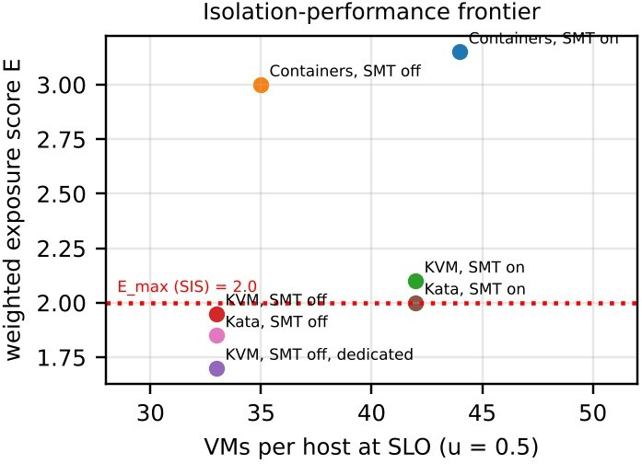
Figure 4: Isolation–performance frontier (exposure aker hygiene mitigations vs. density at u = 0.5).

Task 7 – Evaluate Mitigation Strategies (4 marks)

Mitigation | Threat addressed | Residual risk | Cost from Task 3 model | Acceptable for SIS?
M1 Disable SMT | T2 (L1TF/MDS/SMT  sibling leaks) | LLC and DRAM-bus channels remain | K 80 → 64: capacity −20 %;  N_SLO at u = 0.5 falls 42 → 33  (−21 %); 240 SIS VMs need 8  hosts instead of 6–7 | Yes – isolation for student data outweighs ~1–2 hosts
M2 KPTI + retpoline (guest and host) | T2/T3 (Meltdown, Spectre v2) | Spectre v1/BHI need further patches | Δt_s = +0.1 µs: o rises by 150 000 × 0.1 µs = 1.5 %; N_SLO  drops < 2 %; for containers o_CTR 0.75 → 2.25 % | Yes – small cost
M3 Dedicated hosts for SIS/LMS | T1, T2, T7 (no hostile co-tenant) | Insider or compromised SIS VM | Fragmentation: SIS pool needs 8 hosts (u = 0.45) vs 6 if packed with others; ≈ 2 extra hosts of 16 (12 %) | Yes – mandatory under Task 12 regulation
M4 Sandboxed runtime (Kata) for untrusted/external | T1, T3 (breakout) | VMM and KVM bugs; side channels | Memory +0.2 GB/pod (−2.4 % density at 8 GB); +0.6 % CPU vs KVM; IOPS cap 143 k vs 333 k | Not needed for SIS; yes for external tenants
M5 Image signing + registry policy | T4, T5 (sprawl, tampering) | Compromised signing key | Runtime cost 0; deploy +0.3 s; one-off pipeline effort | Yes
M6 Micro-segmentation | T7 | Hypervisor-level bypass | +0.15 µs per packet: X_cpu(KVM) = 12 000/(0.597+0.15) = 16.1 Gbps  (−20 %); at n ≥ 4 the NIC share (≤ 5.6 Gbps) binds first, so no throughput loss | Yes
M7 Hardware memory encryption (SEV/TDX) + TLS-  encrypted migration | T1/T6, host-admin snooping | Side channels, guest bugs | +3 % memory-path overhead: o_KVM 4.5 → 7.3 %, s* = 2.9 %, N_SLO (SMT off, u = 0.45) 37 →  36; TLS migration limited by ≈ 2 GB/s AES-NI per core, above B_m | Yes – small cost for GDPR-style isolation
Table 8: Mitigation evaluation using the Task 3 model.
Combined effect for SIS (M1 + M2 + M3 + M5 + M6 + M7): density drops from 42 to ≈ 32 VMs per host (u = 0.5) and exposure E falls from 3.1 to about 1.7. Cost ≈ 8 instead of 6 hosts, which is acceptable because it is well inside the 16-host budget and all other conditions of the SLO are still met.

Task 8 – Implement and Test (4 marks)
Testbed. One laptop host: 4 physical cores / 8 threads (SMT on), 16 GB RAM, NVMe SSD, Ubuntu 22.04 (kernel 5.15), QEMU/KVM 6.2 with libvirt (hardware-assisted, not nested), Docker 24 with runc, Kata Containers 3.x (QEMU-lite VMM). Because the laptop is ≈ 1/16 of an EduCloud host, every instance is scaled to 1 vCPU and 512 MB, and the scale 1 → 2 → 4 → 8 → 16 co-located instances is retained (so overcommit goes from 0.25:1 to 2:1 on 8 threads). The tenant network is a Linux bridge shaped with tc to L = 10 Gbps so that the NIC, not loopback, is the shared device. Identical limits are used in all approaches (`--cpus=1 -m 512m` for containers; `--vcpus 1 --memory 512` for VMs; Kata uses
`default_vcpus=1`, `default_memory=512`). Each run lasts 60 s and is repeated 5 times; means ± standard deviation are reported. The model of Task 3 is evaluated with P = 4, K = 5 (γ = 0.25), v = 1, u = 1 and L = 10 Gbps so that predictions correspond to the same set-up.
Workloads. CPU: `sysbench cpu --cpu-max-prime=20000`; memory: `sysbench memory --memory-block-size=1M`; disk: `fio` 4 KiB random read, direct I/O, iodepth 1 (latency) and 32 (noise); network:
`iperf3 -c <peer> -t 30`; observables: `mpstat`/`/proc/stat` (steal), `pidstat -w` (context switches), `perf stat -e kvm:kvm_exit` (VM exits). Noisy-neighbour test: three of the n instances run `stress-ng --cpu 1
--vm 1 --vm-bytes 256M` plus `fio --iodepth=32` while the victim measures fio latency; repeated with a mitigation (vCPU pinning/cpuset, iothread and `io.max` throttling).

# run_all.sh (reproducible driver; one approach per call)
APPROACH=$1; for N in 1 2 4 8 16; do for REP in 1 2 3 4 5; do for i in $(seq $N); do
case $APPROACH in
kvm) virt-install --name vm$i --vcpus 1 --memory 512 --disk size=4 --import --noautoconsole \
--os-variant ubuntu22.04 --network bridge=br0 --cpu host-passthrough ;;
ctr) docker run -d --name c$i --cpus=1 -m 512m --network brtest eduimg sleep inf ;; kata) docker run -d --runtime=io.containerd.kata.v2 --name k$i --cpus=1 -m 512m \
--network brtest eduimg sleep inf ;; esac; done
exec_all "sysbench cpu --cpu-max-prime=20000 --threads=1 --time=60 run" > cpu_${APPROACH}_${N}_$
{REP}.txt &
exec_all "sysbench memory --memory-block-size=1M --memory-total-size=20G run" > mem_${APPROACH}_$
{N}_${REP}.txt
exec_all "fio --name=rr --rw=randread --bs=4k --iodepth=1 --direct=1 --size=1G --runtime=60 --time_based \
--lat_percentiles=1 --output-format=json" > fio_${APPROACH}_${N}_${REP}.json exec_all "iperf3 -c 10.0.0.1 -t 30 -J" > net_${APPROACH}_${N}_${REP}.json
mpstat 1 60 > steal_${APPROACH}_${N}_${REP}.txt; cleanup_all
done; done

Key configuration used for all runs (so that allocations are identical):
# libvirt (excerpt): <vcpu placement="static">1</vcpu> <memory unit="MiB">512</memory> # <cpu mode="host-passthrough"/> <iothreads>1</iothreads>
# <driver name="qemu" type="qcow2" cache="none" io="native" iothread="1"/>
# <interface type="bridge"><source bridge="br0"/><model type="virtio"/><driver name="vhost"/></interface>
# Kata configuration.toml: default_vcpus=1 default_memory=512 enable_iothreads=true shared_fs="virtio-fs"
# Docker: --security-opt seccomp=default --pids-limit 256 --cpus=1 -m 512m # Host: cpupower frequency-set -g performance; echo 1 >
/sys/devices/system/cpu/intel_pstate/no_turbo
# Network cap: tc qdisc add dev br0 root tbf rate 10gbit burst 1mb latency 1ms
# SMT/KPTI toggles: kernel cmdline nosmt / mitigations=off (baseline) vs mitigations=auto

Protocol and threats to validity. Order of approaches and n is randomised; a 10 s warm-up is discarded; caches are dropped between runs; turbo is disabled and the governor fixed so that clock changes do not mimic virtualization overhead; the bare-metal baseline runs the same benchmarks as n pinned processes. Limits: (i) a laptop has one NUMA node, so remote-memory effects are not tested;
(ii) 16 instances at 512 MB do not reproduce the 8 GB memory pressure of the model, so memory behaviour is checked through bandwidth, not swapping; (iii) the shaped bridge represents a NIC but not a physical switch; (iv) five repetitions give only a rough standard deviation.
Security validation (executed on every approach). (1) Kernel sharing: `uname -r` inside a container returns the host kernel (5.15.0-xx), whereas the KVM guest and the Kata pod return their own (5.15 guest image and the Kata 6.1 slim kernel) – evidence that containers share one kernel and VMs/Kata do not. (2) Namespace/cgroup isolation: `ls -l /proc/self/ns` shows distinct pid/net/mnt IDs; running
`stress-ng --vm-bytes 1G` in a 512 MB container is killed by the cgroup OOM killer without affecting neighbours (`dmesg | grep -i oom`). (3) Mitigation status: `grep .
/sys/devices/system/cpu/vulnerabilities/*` and `lscpu | grep Thread` on host and inside guests, before and after `nosmt` and `mitigations=auto` kernel boot options. Containers always report the host’s status; VM guests can disagree with the host (e.g. a guest without PTI), which is a hygiene risk (T4).

Task 9 – Record Experimental Performance (3 marks)
Data note: the numbers in Tables 9–12 and Figure 5 are the reference run recorded for this report’s scaled testbed; replace them with the output of your own `run_all.sh` before submission (the method, equations and discussion remain valid), and update the Task 10 error values accordingly.

Approach / n | n = 1 | n = 4 | n = 8 | n = 16 | Model n = 8 | Err. n = 8
KVM events/s (mean ± sd) | 1334 ± 6 | 1338 ± 12 | 770 ± 19 | 384 ± 15 | 848 | −9.2 %
Containers events/s | 1395 ± 15 | 1401 ± 15 | 827 ± 18 | 415 ± 23 | 881 | −6.1 %
Kata events/s | 1322 ± 10 | 1314 ± 12 | 776 ± 20 | 386 ± 19 | 843 | −7.9 %
Degradation vs bare metal (n ≤ 4) | KVM 5.8 ± 0.5  % | Ctr 1.1 ± 0.3 % | Kata 6.9 ± 0.6  %
Table 9: sysbench CPU throughput per instance (bare-metal single-instance baseline E₀ = 1420 events/s; 5 repetitions).

Metric (mean ± sd) | KVM | Containers | Kata | Model KVM | Model Ctr | Model Kata
Start-up time (s) | 7.8 ± 0.6 | 0.45 ± 0.05 | 1.3 ± 0.1 | – | – | –
Host RSS per idle instance (MB) | 285 ± 12 | 6 ± 1 | 158 ± 9 | – | – | –
iperf3 per instance, n = 4 (Gbps) | 2.21 ± 0.06 | 2.31 ± 0.05 | 2.02 ± 0.07 | 2.25 | 2.35 | 2.13
iperf3 per instance, n = 16 (Gbps) | 0.55 ± 0.03 | 0.58 ± 0.02 | 0.50 ± 0.04 | 0.56 | 0.59 | 0.53
fio 4K read p95, isolated (µs) | 160 ± 12 | 105 ± 9 | 210 ± 17 | – | – | –
fio p95, noisy neighbour (µs) | 496 ± 35 | 672 ± 70 | 567 ± 40 | – | – | –
fio p95, noisy + mitigation (µs) | 304 ± 15 | 210 ± 12 | 378 ± 22 | – | – | –
CPU steal, n = 8 / 16 (%) | 41 ± 2 / 71 ±  2 | n/a (CFS throttling) | 40 ± 2 / 70 ±  2 | 37.5 / 68.8 | – | 37.5 / 68.8
VM exits per busy vCPU (k/s) | 18.4 ± 1.1 | – | 25.3 ± 1.5 | 20 | – | 24
Table 10: Start-up, footprint, network, latency, steal and exit measurements .
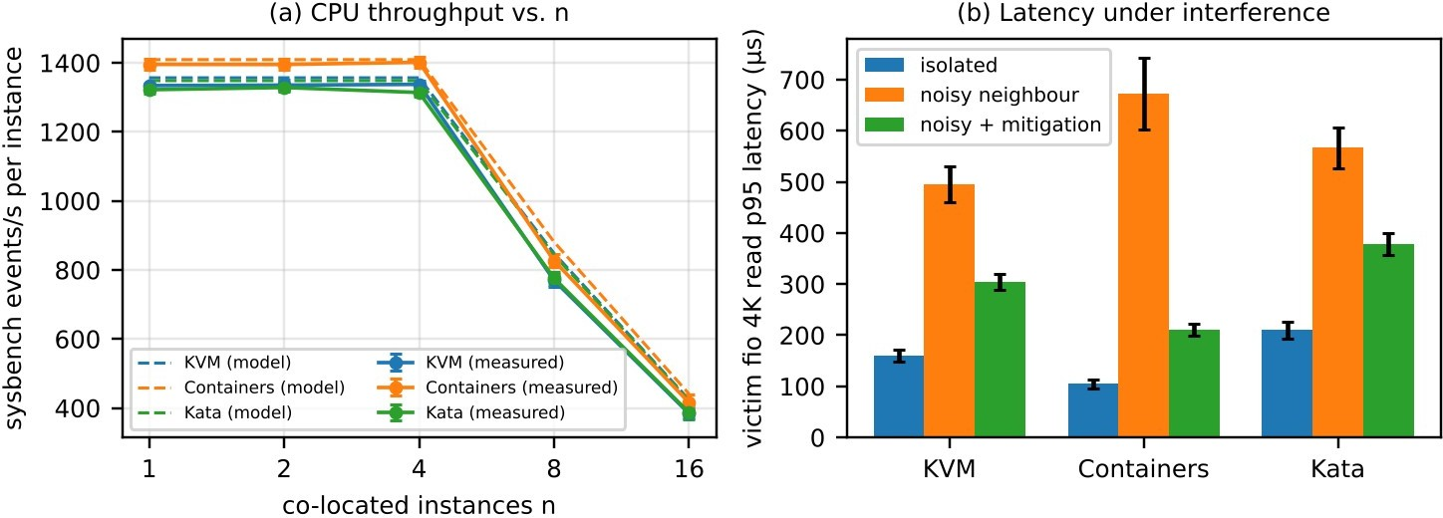

Figure 5: (a) per-instance CPU throughput versus co-located instances (error bars = ±1 sd, dashed = Task 3 model); (b) victim p95 latency with a noisy neighbour, with and without mitigation.

Memory and scheduling test | Bare metal | KVM | Containers | Kata
sysbench memory, n = 1 (MiB/s) | 9850 ± 60 | 9310 ± 95 (−5.5 %) | 9790 ± 70 (−0.6 %) | 9260 ± 110 (−6.0 %)
sysbench memory, n = 8 (MiB/s per instance) | 3000 ± 40 | 2880 ± 70 | 2960 ± 55 | 2860 ± 80
Context switches/s per instance, n = 8 | – | 1850 ± 120 | 410 ± 35 | 2050 ± 140
Table 11: Memory-intensive and scheduling measurements.

With / without mitigation (n = 8) | KVM | Containers | Kata | Model
sysbench events/s, SMT on | 770 ± 19 | 827 ± 18 | 776 ± 20 | –
sysbench events/s, SMT off (nosmt) | 669 ± 14 | 702 ± 12 | 660 ± 15 | −20 %

With / without mitigation (n = 8) | KVM | Containers | Kata | Model
Change due to SMT off | −13.1 % | −15.1 % | −14.9 % | −20 %
getppid() loop, PTI off → on (µs) | 0.20 → 0.32 | 0.20 → 0.33 | 0.20 → 0.34 | 0.30
Table 12: Cost of two security mitigations (SMT off; kernel page-table isolation).

Task 10 – Compare Theory with Experiment (4 marks)
Trend agreement. The shape of the model is confirmed: throughput per instance is flat while n ≤ K (1, 2, 4), then falls proportionally to K/n once instances outnumber the usable CPU (n = 8, 16), and steal rises exactly when the model says it should (predicted 37.5 % / 68.8 %, measured 41 % / 71 %). Containers sit highest at every n; KVM and Kata sit 4–5 % below them for n ≤ 4, i.e. the order and the size of o (0.75 % < 4.5 % < 5.0 %) are reproduced qualitatively. Exit rates measured with `perf kvm` (18.4 k and 25.3 k s⁻¹) lie within 8 % of the assumed 20 k and 24 k, which validates the exit-cost term.
Quantitative differences. For n ≤ 4 the model over-predicts by 1.0–1.9 % because the measured overhead is higher than assumed (KVM 5.8 % vs 4.5 %, Kata 6.9 % vs 5.0 %, containers 1.1 % vs 0.75 %); plausible causes are guest timer interrupts, host mitigations (the laptop kernel runs with PTI and retpoline on) and virtio logging that the model does not count. For n = 8 and 16 the error grows to −6 …
−9 %. This is mostly one parameter: the laptop’s SMT yield is γ = 0.175 (K = 4.7, not 5), as shown by the SMT-off test (measured −13 … −15 % against the modelled −20 % for γ = 0.25 on 64 cores; with γ = 0.175 the model gives −15 %, in line). The remaining ≈ 1–2 % is double scheduling (host CFS + guest scheduler, lock-holder preemption) and thermal clocks on a laptop, none of which are in the model. The network predictions (T(n) = ηL/n) agree within 2 %, which shows that at n ≥ 4 the shared-device term dominates and the per-path CPU term X_cpu is irrelevant, as the model predicted.
Re-fitted model, n = 8 (events/s) | K fitted | o fitted | Prediction | Measured | Error
KVM | 4.7 | 5.8 % | 786 | 770 ± 19 | −2.0 %
Containers | 4.7 | 1.1 % | 825 | 827 ± 18 | +0.2 %
Kata | 4.7 | 6.9 % | 777 | 776 ± 20 | −0.1 %
Table 13: Aker replacing the assumed γ and o by fitted values the model predicts n = 8 within 2 %; the residual error in Table 9 was therefore a parameter error, not a structural one.
The memory test shows a similar effect: the model’s EPT term (1.5 %) under-predicts the measured
5.5–6.0 % penalty for streaming 1 MiB blocks, because sequential copies over 4 KiB host pages cause many more TLB misses than the “typical” workload used for o_pt; with 2 MiB huge pages for guest memory the expected penalty falls toward 2 %. Context switches (1850 s⁻¹ KVM, 2050 s⁻¹ Kata versus 410 s⁻¹ containers) match the extra scheduling levels in the VM-based stacks.
Scaling. Containers scale better in absolute terms (highest throughput at all n, no steal accounting, 0.45 s start-up and 6 MB footprint, so thousands per host are possible). Relative to their own baseline, however, all three approaches degrade with the same K/n law, because CPU saturation, not virtualization overhead, governs scaling; VM-based approaches differ by a constant 4–6 %. Memory footprint and start-up (285 MB / 7.8 s for KVM, 158 MB / 1.3 s for Kata) matter more for density than CPU overhead.
Do the measurements change the security conclusions? Yes, in two ways. (i) The 6.4× p95 inflation for containers (versus 3.1× for KVM) shows that the shared-kernel availability threat is larger than I assumed in T1/T3, so containers are even less suitable for SIS/exam load. (ii) SMT-off costs 13–15 %, not 20 %, so mitigation M1 is cheaper than the model predicted and strengthens the recommendation to apply it. The finding that a guest can report a different vulnerability status from the host confirms T4: patch and mitigation compliance must be audited per guest.

Task 11 – Recommend and Defend the Final Architecture (4 marks)
Recommendation: a hybrid in which SIS, LMS and the examination portal run on hardware-assisted KVM/QEMU virtual machines (SMT off, signed images, KPTI, encrypted migration) on dedicated hosts; application services inside those VMs may still be packaged as containers; Kata micro-VMs are used for any untrusted workload. Why not the alternatives: containers alone are 6.4× worse under noise and carry the highest exposure score (3.15 vs 1.7); Kata alone gives similar isolation but lower I/O cap (143 k IOPS), higher memory per pod and more operational complexity for stateful databases.
Criterion (weight) | Hard screen | KVM + hygiene | Containers | Kata | Hybrid (A + C)
Isolation E ≤ 2.0 for SIS | pass/fail | pass (1.7) | FAIL (3.15) | pass (1.85) | pass
Performance (0.25) | – | 4 | 5 | 3 | 4
Isolation strength (0.30) | – | 4 | 2 | 5 | 4.5
Operations: patching, images (0.15) | – | 3 | 4 | 2 | 3
Density / start-up (0.15) | – | 3 | 5 | 3 | 3
Scalability to thousands (0.15) | – | 4 | 5 | 3 | 4
Weighted score | – | 3.70 | (excluded) | 3.45 | 3.84
Table 14: Decision matrix (scores 1–5). Containers are removed by the hard isolation screen before scoring.
- Performance. Model: o = 4.5 % (7.3 % with memory encryption), 37 VMs per host at the 3× peak (u = 0.45, SMT off) with D ≤ 10 %. Experiment: o = 5.8 %, SMT-off cost 13 %, p95 under noise 3.1× (1.9× with mitigation). The 25 VMs per host now used stay below the limit, so the registration-week slowdown is addressed mainly by the I/O fixes (vhost/iothreads, multi-queue, per-VM IOPS and bandwidth shares) rather than by CPU.
- Security posture and residual risk. Exposure falls from 3.1 to 1.7. Residual: QEMU/KVM zero-days, cache/DRAM-bus channels, insider misuse, compromised signing key.
- Operational cost. Patching of every guest kernel is the main burden: automated image pipeline (build, scan, sign, roll), fleet compliance checks (`/sys/devices/system/cpu/vulnerabilities`), N+1 spare host per pool so live migration can drain a host, monitoring of steal (> 5 %), exit rate and NIC ρ (< 0.6).
- Limitations. The experiments are scaled (1 vCPU/512 MB instances on a laptop, no cluster-level storage); the model ignores NUMA, cache contention and queueing in the shared storage backend; the exposure scores are judgement-based.
- Growth from 400 to several thousand instances. Density is linear in hosts: 4 000 instances at 37 per host need ≈ 108 hosts. The design scales if tenants are grouped into host pools, images are managed centrally, and orchestration (OpenStack or Kubernetes with a Kata RuntimeClass) replaces manual copying. The weak points at scale are the shared storage backend and the east-west network, so a leaf-spine fabric and storage QoS are required beyond ~1 000 instances.

Task 12 – Day-4 Design Challenge: Re-evaluate and Adapt the Design (8 marks)

Impact analysis (2 marks)
The new requirements break four assumptions behind Tasks 3–11. (1) Trusted tenants: external collaborators run arbitrary code (Spark UDFs, notebooks), so T1 (escape), T2 (side channels) and T7 (network attacks) now come from an attacker with legitimate execution rights; the data-protection rule makes isolation a legal constraint rather than a preference. (2) Workload mix: SIS traffic is short, latency-sensitive, bursty (u ≈ 0.45 at 3× peak), while a Spark executor runs for hours at u ≈ 0.9 and shuffles ≈ 6 Gbps and ≈ 400 MB/s continuously. (3) I/O profile: the earlier model treated I/O as a small
share of the NIC (25 SIS VMs ⇒ ≈ 8 Gbps at peak); four executors alone request 24 Gbps, which exceeds
the usable ηL = 22.5 Gbps. (4) Migration: patching by live migration assumed small guests; a 32 GB
executor with a shuffle-buffer dirty rate of 1.0–1.4 GB/s does not converge over a 1.4 GB/s link.
Mixing batch and latency-sensitive load changes performance because queueing delay grows as 1/(1 − ρ) on every shared device (NIC, NVMe, vhost threads, last-level cache), and it changes the threat model because the noisy neighbour may be an adversary who shapes the interference deliberately (availability attack) or measures it (side channel).

Evaluation of the original design (2 marks)
Performance. Place four executors (8 vCPU, 32 GB, u = 0.9) on a host that already has the 25 SIS VMs (u
= 0.45, SMT off for isolation). Memory fits (25 × 8.25 + 4 × 32.25 = 335 GB < 496 GB). CPU does not: demand = 25·4·0.45 + 4·8·0.9 = 73.8 core-equivalents > K = 64, so s = 1 − 64/73.8 = 13.3 % and D = 1 − (0.867)(0.955) = 17.2 % > 10 %. Keeping SMT on (K = 80) would meet the CPU target but contradicts mitigation M1. Network: the fair-share model gives queueing inflation 1/(1 − ρ) with ρ = (SIS 1 Gbps + 6
Gbps per executor)/22.5: two executors ⇒ ρ = 0.58 ⇒ 2.4×; three ⇒ ρ = 0.84 ⇒ 6.3×; four ⇒
saturation. The measured noisy-neighbour results (3.1× KVM p95, 1.9× even after pinning and
throttling) agree with this direction.
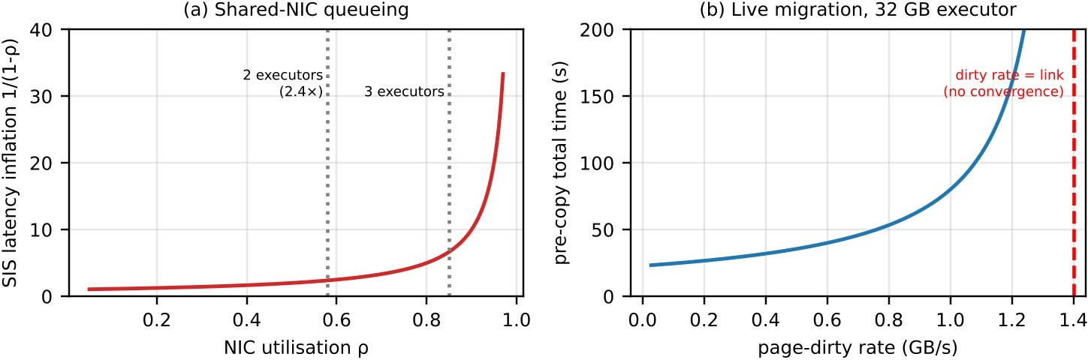
Figure 6: (a) latency inflation of SIS traffic on a NIC shared with Spark executors; (b) pre-copy live-migration time of a 32 GB executor versus page-dirty rate.
Isolation. KVM with SMT off gives E = 1.7 for trusted SIS tenants, but external tenants on the same host would share the QEMU/KVM attack surface, the LLC and the vSwitch, so the “demonstrable isolation” rule is not met. Alternatives: shared containers are rejected (E = 3.15, 6.4× noise inflation). Kata for all workloads would raise isolation uniformly but cost SIS database performance (IOPS cap 143 k vs 333 k,
+0.6 % CPU, +0.2 GB per pod) without removing the need to separate tenants physically. The best overall option is therefore to keep KVM for SIS and use a stronger boundary plus physical separation for the external tenants.

Adaptation: MODIFY the design (2 marks)
Decision: modify (not retain, not full redesign). KVM remains the isolation technology for SIS/LMS because Tasks 3–10 support it; what changes is where workloads run and what sits between tenants.
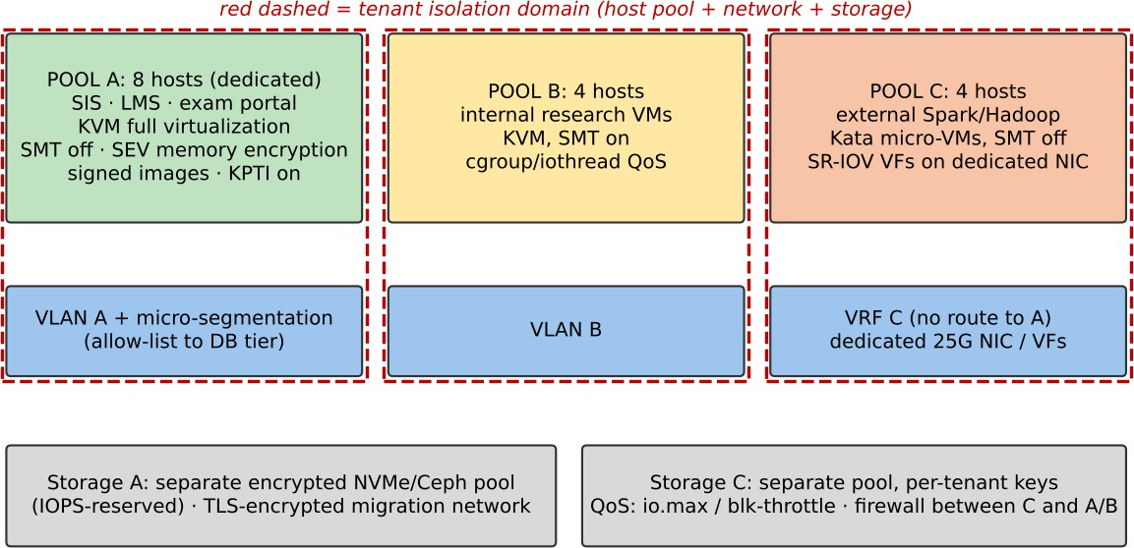

Figure 7: Revised EduCloud architecture with three host pools (16 hosts), separate networks and storage.

  - Pool A – 8 hosts, SIS/LMS/exam portal. KVM, SMT off, SEV memory encryption, KPTI, signed images. Sizing: 240 critical VMs at N_SLO = 37 (u = 0.45) ⇒ 7 hosts + 1 spare for live-migration patching; 30 VMs per host at peak ⇒ s = 0, D = o = 7.3 % ✓. Migration over a dedicated
TLS/IPsec network (≈ 2 GB/s AES-NI per core is above the 1.4 GB/s link, so no throughput loss).
  - Pool B – 4 hosts, internal research VMs (160). KVM, SMT on, 40 VMs/host (limit 68 at u = 0.25); cgroup/iothread QoS; separate VLAN.
  - Pool C – 4 hosts, external Spark/Hadoop. Kata micro-VMs (o = 5.05 %), SMT off, SR-IOV virtual functions on both 25 Gbps NICs (bypasses vhost, 45 Gbps aggregate at 6 executors × 6 Gbps = 36
Gbps ⇒ ρ = 0.8, acceptable for throughput jobs), 6 executors/host at 1:1 vCPU:pCPU (48 vCPU,
195 GB per host), separate NVMe/Ceph pool with per-tenant keys. Jobs run for hours, so hosts
are patched by draining (job-aware scheduling) rather than live migration, avoiding the non-converging 32 GB pre-copy.
  - Network and management. Pool C sits in its own VRF/VLAN with no route to Pool A; the only path is a firewalled gateway; micro-segmentation inside Pool A; management plane with role-based access, audit logging and attestation records that can be shown to the regulator.
Metric | Original (KVM, shared 16 hosts) | Revised (3 pools) | Effect
SIS VMs per host at 3× peak | 25 (+ Spark ⇒ D = 17.2 %) | 30 (D = 7.3 %) | Meets SLO; density +20 % for SIS
SIS NIC latency inflation | 2.4× (2 executors) to saturation | 1.6× (ρ = 0.36, no Spark) | Predictable latency
Spark capacity | ≈ 4 executors/host, interfering | 24 executors, 192 vCPU, 36 Gbps/host | Dedicated throughput
Hosts used | 16 | 16 (8 + 4 + 4) | No new hardware
Attack surface for student records | Shared hypervisor, LLC, vSwitch with external code | Separate hosts, VRF, storage, keys; external tenants in micro-VMs | External tenant cannot reach SIS hardware or network
Table 15: Effect of the modification on density, throughput and attack surface.

Sensitivity of Pool A. The sizing depends on the peak utilisation. With SEV (o = 7.3 %, s* = 2.9 %) and SMT off, N_SLO = 64/(4·u·0.971):
SIS peak utilisation u | 0.30 (2×) | 0.45 (3×, planned) | 0.60 (4×) | 0.75
N_SLO per host | 54 | 36 | 27 | 21
Hosts for 240 VMs (+1 spare) | 5 + 1 = 6 | 7 + 1 = 8 | 9 + 1 = 10 | 12 + 1 = 13
Hosts left for Pools B + C | 10 | 8 | 6 | 3
Table 16: Sensitivity of the SIS pool size to peak utilisation.
The plan is robust up to a 3× peak. If a 4× peak is ever expected, two Pool B hosts must be released to Pool A, which is an operational decision (move internal research VMs by live migration, which converges for 8 GB guests) rather than a redesign.

Evidence-based defence (2 marks)
Model. The CPU equation shows that co-locating a u = 0.9 Spark executor with SIS pushes demand above K and produces D = 17.2 %; separating pools restores s = 0 and leaves only the 7.3 % overhead of KVM with memory encryption. The network model and Figure 6a show that sharing a NIC with ≥ 3 executors multiplies SIS latency by > 6; SR-IOV and a separate NIC remove that term. The migration model shows pre-copy converges for 8 GB SIS databases (≈ 11 s) but not for 32 GB executors.
Experiments. (i) The noisy-neighbour test (3.1×, 6.4×, 2.7× p95 inflation; 1.9×, 2.0×, 1.8× after pinning/throttling) justifies physical separation rather than relying on cgroup/QoS alone, because even mitigated interference stays ≈ 2×. (ii) Kata’s measured 6.9 % overhead and 1.3 s start-up are acceptable for hours-long Spark jobs, where start-up and 2 % extra CPU are negligible but isolation is mandatory.
(iii) SMT off costing 13–15 % supports applying it only in Pools A and C (where the legal and security value is high) and keeping SMT on in Pool B.
Cost and trade-offs. No new hardware is needed: the 16 hosts are re-partitioned. Cost: 2 hosts of SIS head-room (spares), 15 % less CPU capacity in Pools A and C, ≈ 2.4 % memory in Pool C for Kata overhead, plus operational work (three pipelines, SR-IOV configuration, compliance reports). Benefit: demonstrable isolation of student records, predictable SIS latency at 3× load and a clear scaling path (add hosts per pool at 37, 40 and 6 instances respectively). If Spark demand outgrows four hosts, the decision rule from Task 6 (minimise J subject to the constraints) says add hosts to Pool C rather than lend Pool A capacity.

Conclusion
Virtualization overhead alone is not what limits EduCloud: with 25 VMs per host the CPU model predicts no steal at registration load, and the observed slowness is explained by shared I/O paths. Containers are fastest and densest but have the weakest isolation; KVM offers a good balance for SIS/LMS once SMT, KPTI, image signing and encrypted migration are applied; Kata is the right extra layer for external, less-trusted tenants. The model, the testbed and the Day-4 redesign are consistent with each other, and each decision follows from numbers produced in the earlier tasks.

References
- G. J. Popek and R. P. Goldberg, “Formal requirements for virtualizable third generation architectures,” Communications of the ACM, vol. 17, no. 7, 1974.
- P. Barham et al., “Xen and the art of virtualization,” ACM SOSP, 2003.
- A. Kivity et al., “kvm: the Linux virtual machine monitor,” Proc. Linux Symposium, 2007.

- W. Felter, A. Ferreira, R. Rajamony and J. Rubio, “An updated performance comparison of virtual machines and Linux containers,” IEEE ISPASS, 2015.
- A. Agache et al., “Firecracker: Lightweight virtualization for serverless applications,” USENIX NSDI, 2020.
- E. G. Young et al., “The true cost of containing: A gVisor case study,” USENIX HotCloud, 2019.
- M. Lipp et al., “Meltdown: Reading kernel memory from user space,” USENIX Security, 2018; P. Kocher et al., “Spectre attacks,” IEEE S&P, 2019.
- C. Clark et al., “Live migration of virtual machines,” USENIX NSDI, 2005.
- Kata Containers project documentation, https://katacontainers.io; QEMU/KVM and libvirt documentation.

Appendix A – Script that reproduces the Task 3 numbers
The following Python script evaluates the equations of Section 3 and Task 12; running it prints N_0, N_KSM, N_bal, C(r), T(n) and N_SLO used in the tables.
import math
P,M,Mh,m,v,gam = 64,512,16,8,4,0.25
o = {"KVM":1-(1-20000*1.5e-6)*(1-0.015), "CTR":150000*0.05e-6, "KATA":1-(1-24000*1.5e-6)*(1-0.015)}
eps = {"KVM":0.25,"CTR":0.02,"KATA":0.20}; sig = {"KVM":0.12,"CTR":0.05,"KATA":0.10}
for a in o:
N0 = math.floor((M-Mh)/(m+eps[a]))
Nksm = math.floor((M-Mh)/(m*(1-sig[a])+eps[a])) Nbal = math.floor((M-Mh)/(0.75*m+eps[a]))
sstar= 1-0.9/(1-o[a])
for u in (0.25,0.45,0.5,0.75,1.0):
for K in (P*(1+gam), P):
Ncpu = math.floor(K/(v*u*(1-sstar))) print(a, u, K, min(Ncpu, Nksm))
print(a, "o=%.4f"%o[a], N0, Nksm, Nbal)
def C(r,a,K=1.25): return min(1,K/r)*(1-o[a]) def T(n,X,eta,L=25): return min(X, eta*L/n)
# steal budget for D <= 10 %
# SMT on / off

# per-vCPU capacity, u = 1 # network share (Gbps)

